**User Guide**

* Questions Setting Application

As stated above, this application, as a Web Client, that allow administrators to add-up question providing four possible answers by clicking the Leaflet Map to obtain its coordinates on the web browser, as well as sending those to database server. The user guide is as following:

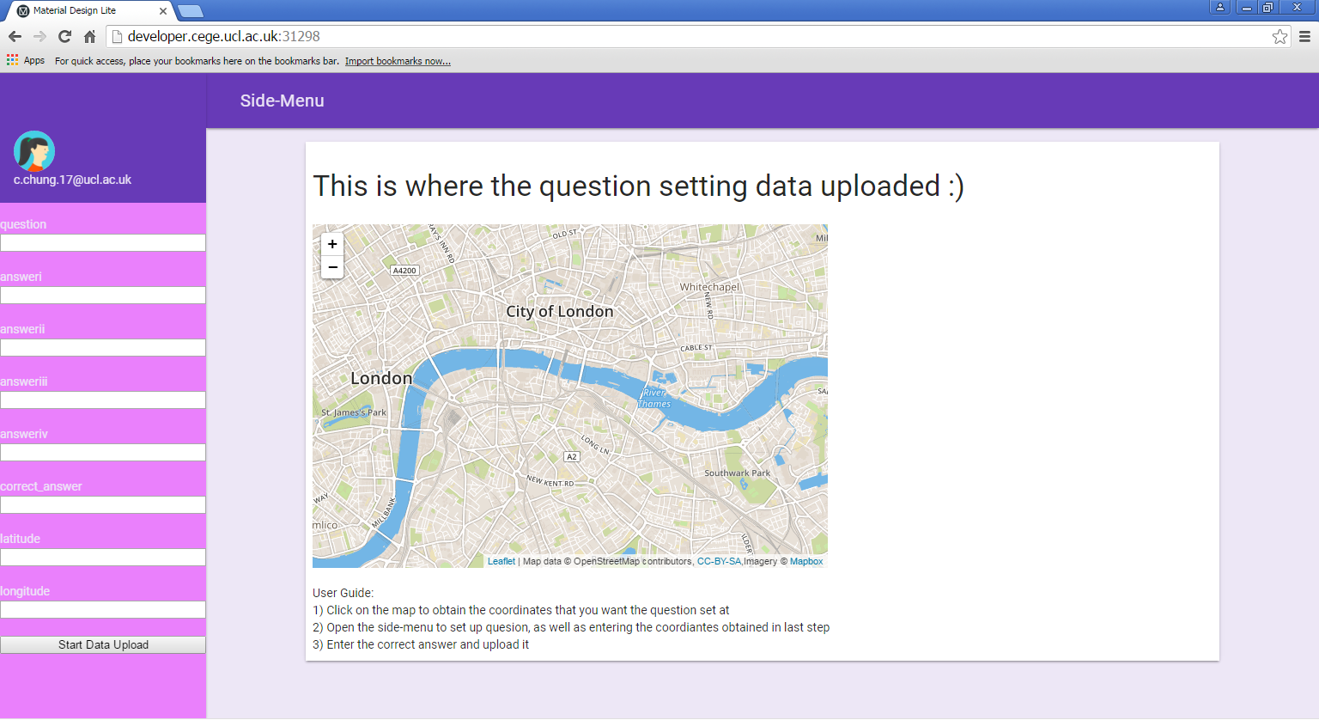

*Figure 2. QSA Setting Layout*

As figure 2 shows, the setting layout is categorize as two main types.

Firstly, on the right side, the Leaflet Map is setting for administrator to obtain the coordinates of specific locations where the questions set at. At the same time, leaf side is a side-menu that is for entering the coordinates that you have just obtained from the map. It also provides a blanket for questionnaire and four possible answers.

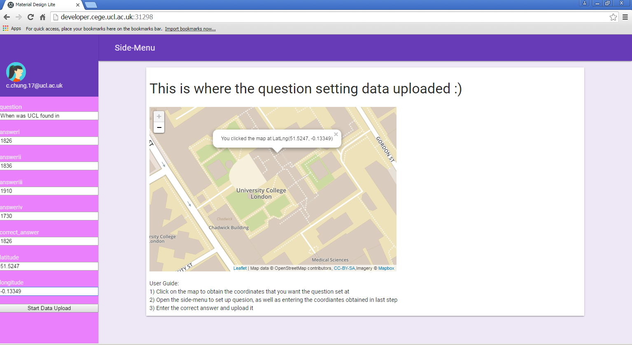

*Figure 3. QSA Setting Layout 2*

After clicking a location on the leaflet map, a coordinate in terms of latitude and longitude will be provided in the map. Next, these set of value can be enter in the setting form in side-menu now. By now, questions and related information can be uploaded to the database server by clicking the “Start Data Upload” buttom.

*Administration Caution

Although the coordinates can be obtained by clicking Leaflet Map, iTouchMap.com is recommend to have more accurate coordinates to prevent any human error while adjust the marker position. The iTouchMap link is <https://itouchmap.com/latlong.html>, where its layout is shown as below:

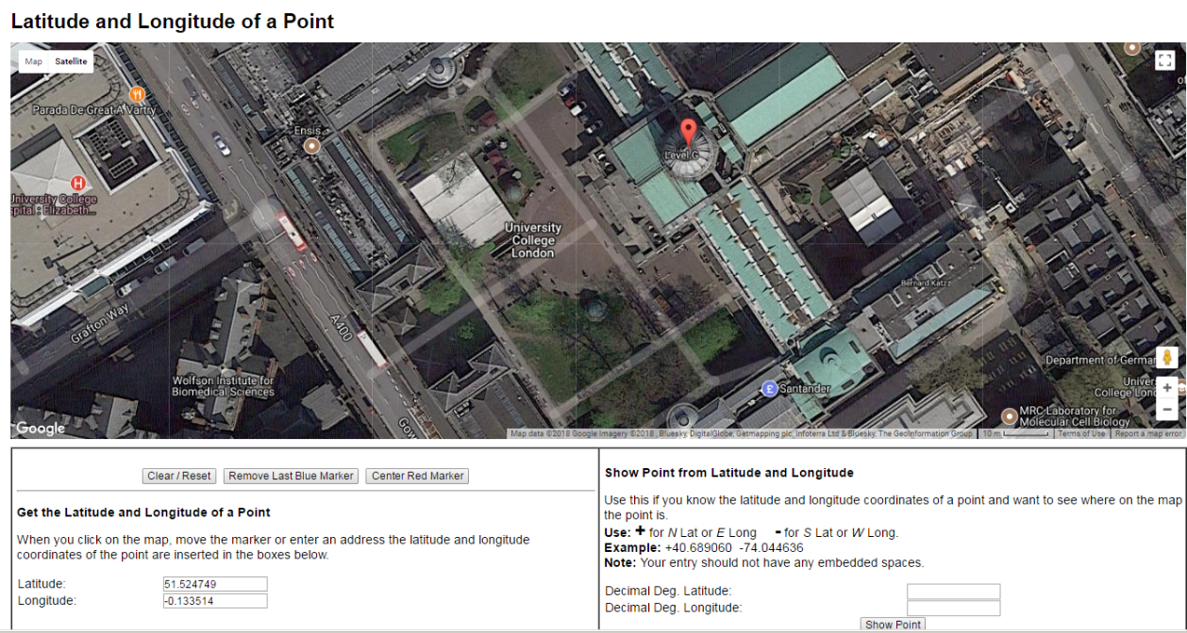

*Figure 4, iTouchMap Setting Example*